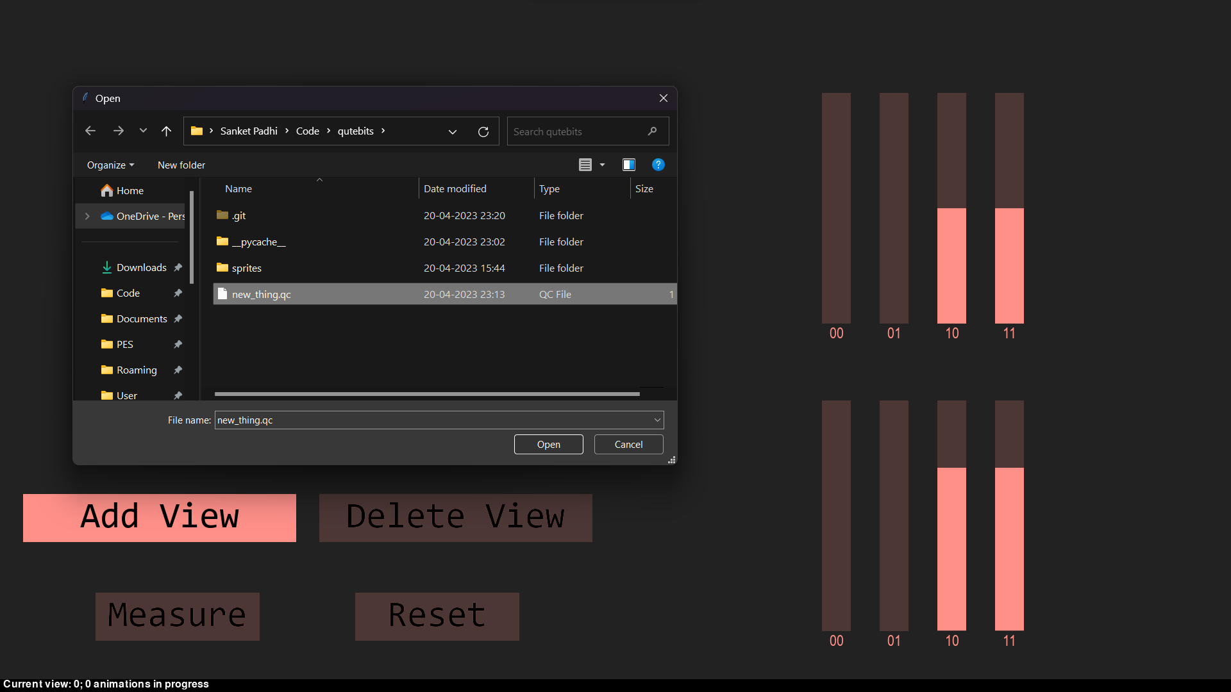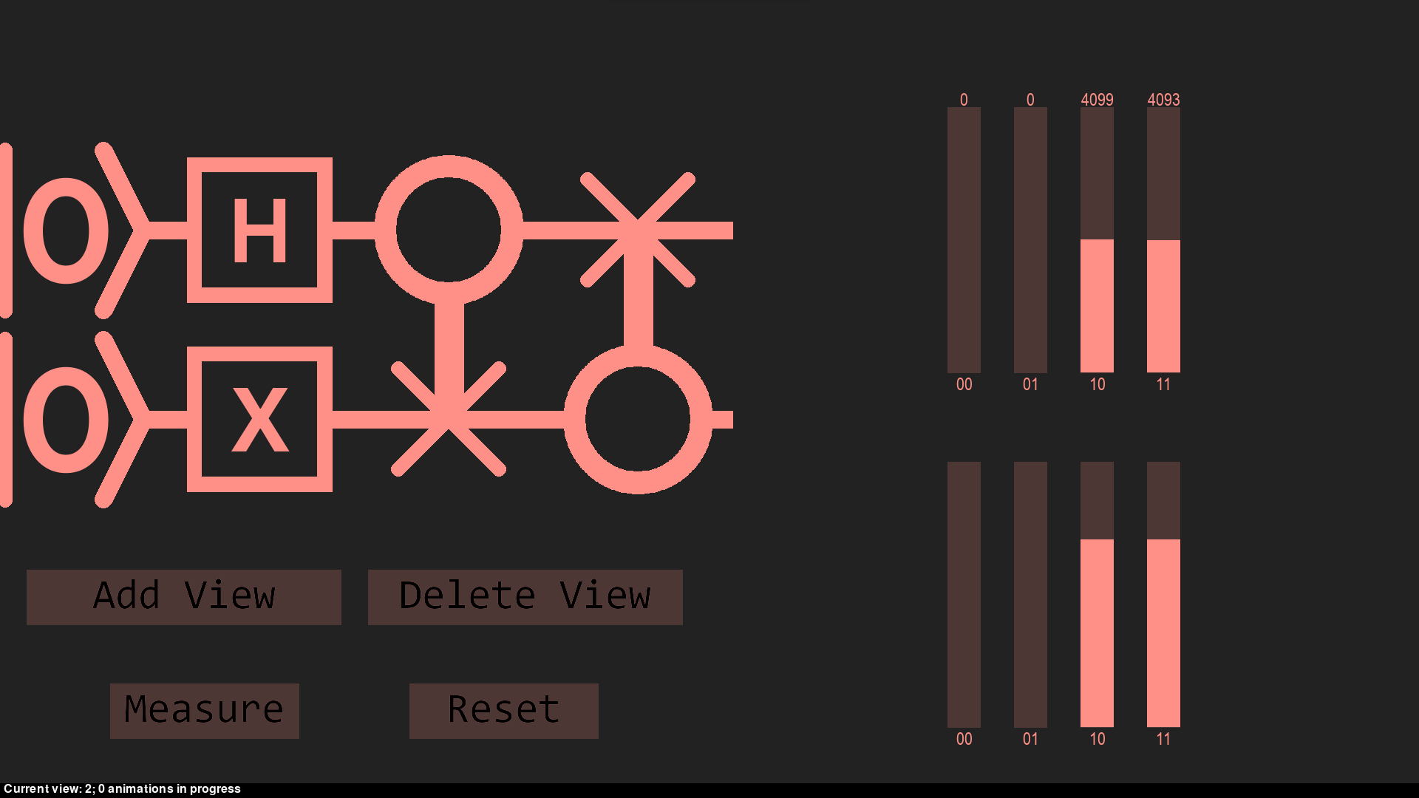

Our GUI interface shows a quantum circuit on the left and two graphs on the right.

The top graph shows the probabilities of the possible outputs and the bottom graph shows the probability amplitudes. The “Measure” button makes a measurement with 8192 shots. The graph changes to shows the number of shots that gave the different states. The “Reset” button resets the measurement graph back to the probabilities.

The interface supports multiple views. Users can add or remove views using the corresponding buttons. Adding a view involves importing a quantum circuit file in our custom file format.

The interface also has animations on the graphs for enhanced user experience.

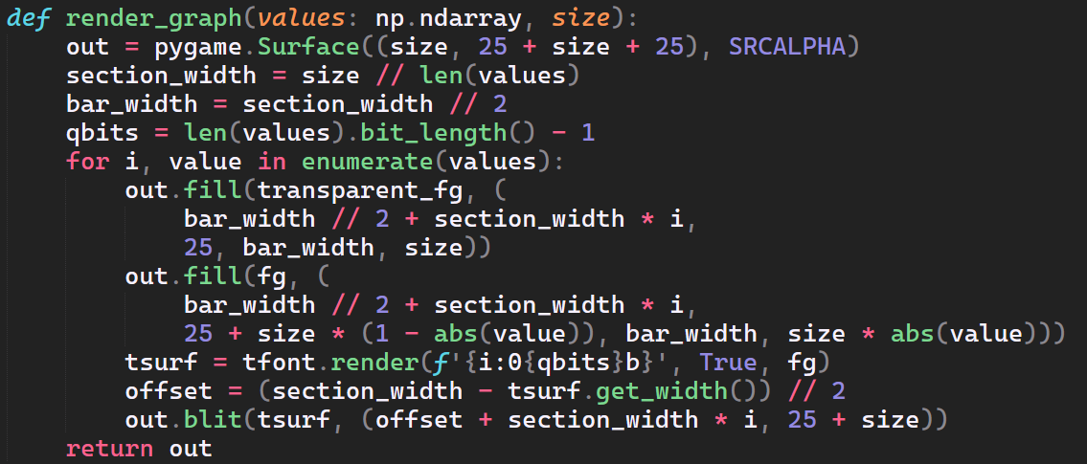

One of the important functions in the interface’s source code is “render_graph”. It renders the graph of probability amplitudes. It does so by iterating through each component of the state vector and creating the corresponding bars in the graph.

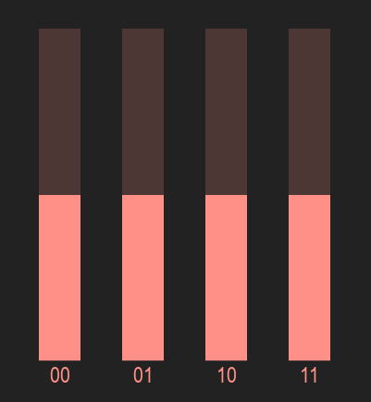

*An example output from the function.*